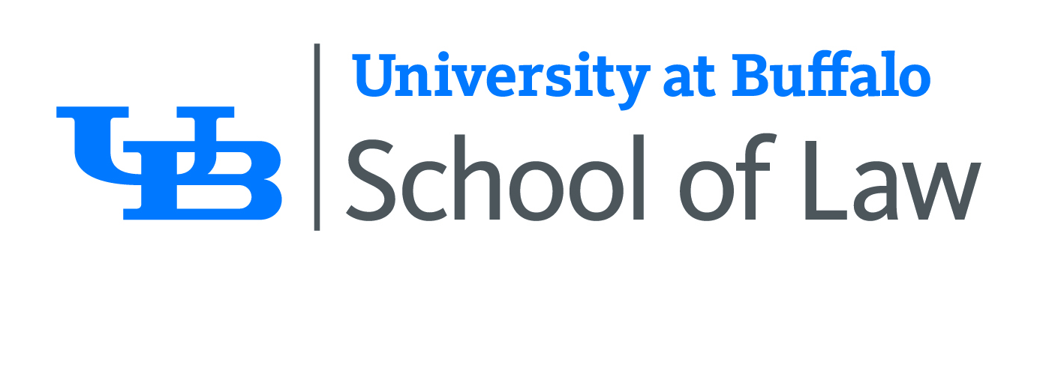

UNIVERSITY AT BUFFALO SCHOOL OF LAW
AND THE UB LAW ALUMNI ASSOCIATION
ATTORNEY AFFIRMATION
New York CLE Credit for Non-Traditional Format Course

I, ________________________________________________________, acknowledge receipt of the
(attorney name)
course materials for: _________________________________________________________________
(course title)
I certify that I have listened to/viewed and/or participated in the above course in its entirety. Therefore, I request that I be awarded the applicable number of New York CLE credits for this course.
Date of completion of CLE course: ____________________________
Format:
□ Videotape □ CD □ DVD □ Live Broadcast/Webcast
During the course or program you will see and/or hear a CLE code. Please enter the code below.
If you do not include the code, you will not be awarded New York State CLE credit.
Course Code: _______________

_________________________________________________________
(signature of attorney)
NOTE: Typing: /s/ before your typed name is an acceptable signature. EXAMPLE: /s/ John Doe

_________________________________________________________
(print name here)

_________________________________________________________
(email address)
To obtain NYS CLE credit, please complete this form and submit it to the law-alumni@buffalo.edu. Once your participation has been verified, we will email you a copy of your New York State CLE Certificate of Attendance.
• New York State attorneys should retain a copy of this affirmation along with their New York CLE Certificate of Attendance.
• Please note that in New York State, one hour of CLE credit consists of at least 50 minutes of instruction. Credit hours must be calculated in no less than 25-minute (.5-hour) increments.

