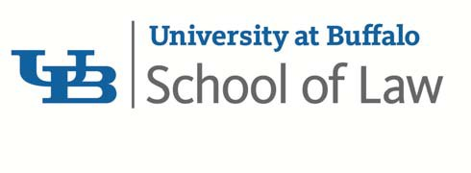

UNIVERSITY AT BUFFALO SCHOOL OF LAW AND THE UB LAW ALUMNI ASSOCIATION

ATTORNEY AFFIRMATION
New York CLE Credit for Non-Traditional Format Course

I, , acknowledge receipt of the
(attorney name)
course materials for:
(course title)
I certify that I have listened to/participated in the above course in its entirety. Therefore, I request that I be awarded the applicable number of New York CLE credits for this course.

Date of completion of CLE course:
Format:
□ Live Broadcast/Webcast □ DVD

Course Code:
During the course or program you will see and/or hear a CLE code. Please enter the code in the above field. If you do not include the code, you will not be awarded New York CLE credit. If there are multiple codes (for example, a separate code for each segment of a program) please enter below:

Code #2:
Code #4:
Code #6:
Code #3:
Code #5:
Code #7:

Attorney’s Mailing Address:

(signature of attorney)

(print name here)

NOTE: Typing: /s/ before your typed name is an acceptable signature. EXAMPLE: /s/ John Doe
To obtain NYS CLE credit, please complete this form and submit it to the law-alumni@buffalo.edu. Once your participation has been verified, we will email you a copy of your New York State CLE Certificate of Attendance.
New York State attorneys should retain a copy of this affirmation along with their New York CLE Certificate of Attendance. Please note that in New York State, one hour of CLE credit consists of at least 50 minutes of instruction. Credit hours must be calculated in no less than 25-minute (.5-hour) increments.

